 **NMAM Institute of Technology **

(An Autonomous Institute Affiliated to VTU, Belgavi)

(A unit of NITTE Education Trust)

NITTE – 574110, UDUPI DIST., KARNATAKA

**DEPARTMENT OF COMPUTER SCIENCE AND ENGINEERING**

**THE YELLOW PIXELS.**

MINI PROJECT ON

**Relational Database Management System**

**MEMBERS:**

1. **Nikhil Kamath B (4NM16CS082)**
2. **P Pawan Bhandarkar (4NM16CS090)**

**Under the Guidance of**

**Mr. Sudeepa K.B**

**Associate Professor**

**Abstract:**

To build a telephone directory system based on an RDBMS approach and provide an interactive GUI for the users to browse through a comprehensive dataset containing the contact information of various businesses and organizations in and around Mangalore. Users are given the option to browse at their own leisure or look up the details of a particular organization from the database at any time. This idea was inspired from the concept of the Yellow Pages telephone directories which were widely used, back in the day.

**Technical Details:**

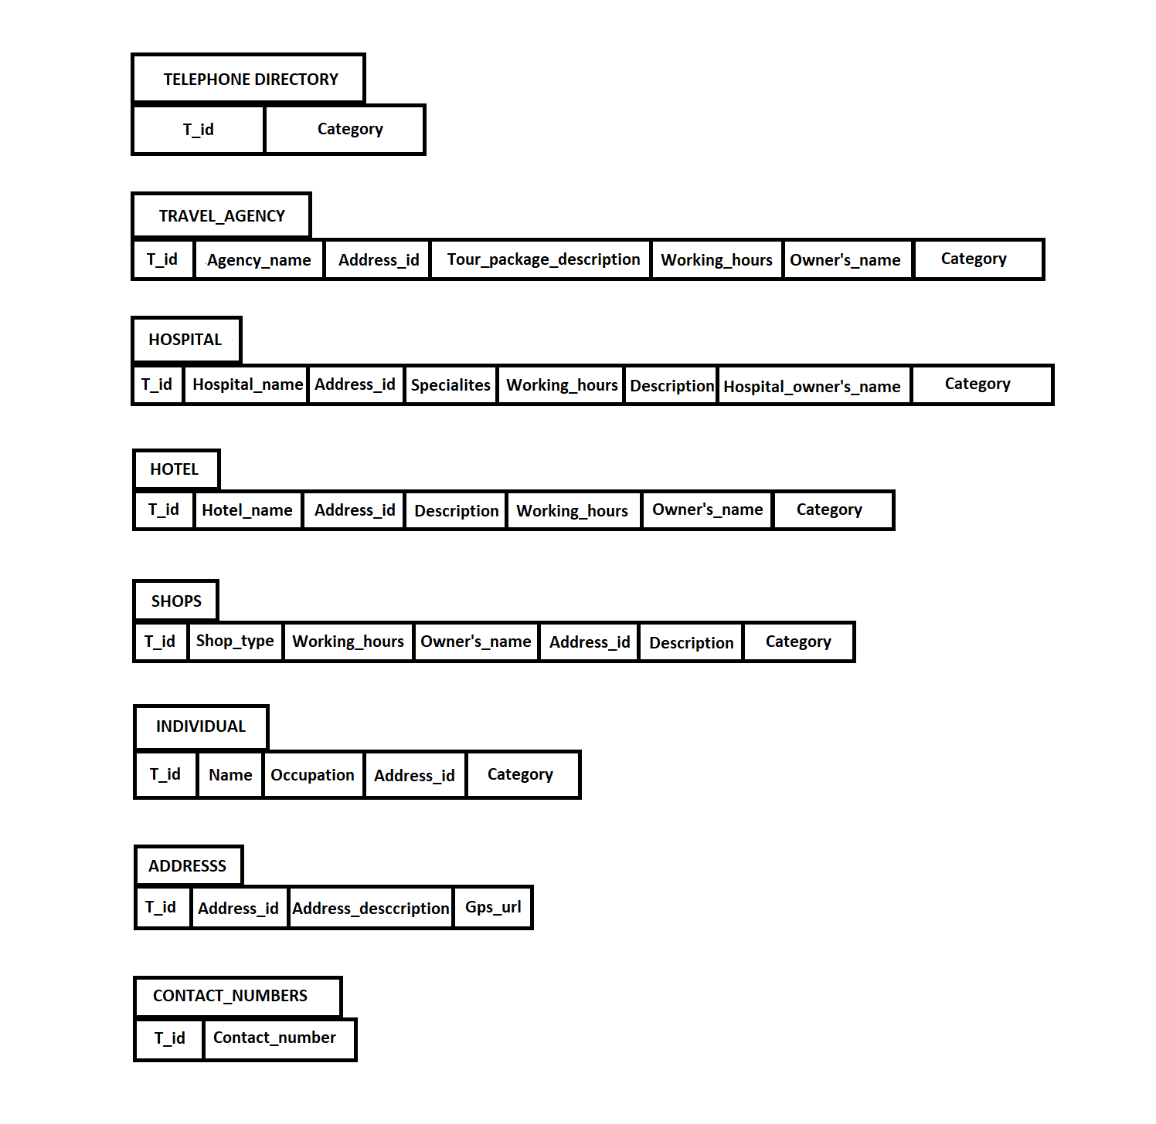

* **Telephone Directory:**

Holds one tuple per organization that has registered to be in the Yellow Pixels. T_id is what will be uniquely identifying each entry and category attribute will be determine what kind of an organization it is (Hospitals, Travel Agencies, Hotels, Shops and Individuals) and will link to the corresponding relation.

* **Travel Agency:**

Holds the data regarding the various Travel Agencies and will be uniquely identified by T_id.

* **Hospital:**

Holds the data regarding various Hospitals and will be uniquely identified by T_id.

* **Hotel:**

Holds the data regarding various Hotels and will be uniquely identified by T_id.

* **Shops:**

Holds the data regarding various Shops and will be uniquely identified by T_id.

* **Individual:**

Holds the data regarding various Individual Businesses and will be uniquely identified by T_id

* **Address:**

Holds the addresses in the form of 3 fields. This will enable easier searching and sorting according to City or State. Address_Id will uniquely identify each address.

* **Contact Numbers:**

As a particular organization can have multiple contact numbers, we decided to maintain a separate table for the same and link it to the organization by means of the T_id.

The project also includes a GUI that allows users to either browse through the database on their own, sort the data according to name, category, city, rating etc. or look up specific businesses based on the organization names or IDs.

Upon searching, the user will be presented with the complete available details about the organization and also an option to rate it on a scale of 0 to 5, which will then be added to the current average and stored.

Each business/organization has its GPS location associated with it which the users can access by means of Google maps and instantly come to know about its whereabouts and also get directions, thanks to the google API

**Innovativeness & Usefulness:**

When complete, the project will provide a window to conveniently accessible information regarding local businesses and allow users to also add their own (new) business details, potentially making way for a new form of publicity and communication for budding companies.

**Software/Tools to be used:**

1. SQL Server Management Studio
2. Atom Text Editor
3. IntelliJ IDEA Community Edition
4. Microsoft Visual Studio

**Things we could add on:**

We can connect each organization to their corresponding social media, if applicable. We could also implement a mobile application version of this. It might also be possible to expand on this idea and implement each “module” even further to include bookings (module = hospital, hotels, shop etc.)

**This synopsis and related schema diagrams are tentative and are subject to change.**